Homophones

🔹 What Are Homophones
# Source: Chatgpt (GPT-4-turbo) at [8/1/2025]
Homophones are words that have the same pronunciation (sound) but different meanings, and often different spellings.
The term comes from Greek: homo = same, phone = sound.
So: “same sound, different meaning (and often spelling)”

🧱 Key Features of Homophones
# Source: Chatgpt (GPT-4-turbo) at [8/1/2025]
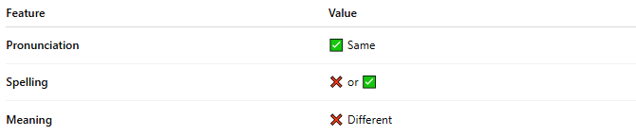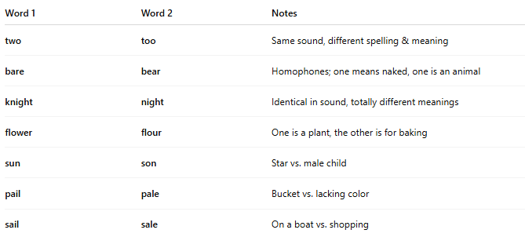
Feature | Value
Pronunciation | ✅ Same
Spelling | ❌ or ✅
Meaning | ❌ Different

📝Examples of Homophones
# Source: Chatgpt (GPT-4-turbo) at [8/1/2025]
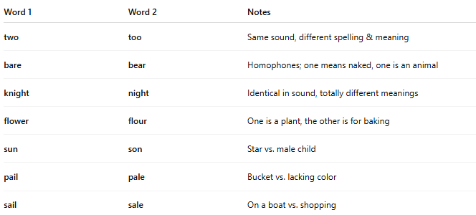
Word 1 | Word 2 | Notes
two | too | Same sound, different spelling & meaning
bare | bear | Homophones; one means naked, one is an animal
knight | night | Identical in sound, totally different meanings
flower | flour | One is a plant, the other is for baking
sun | son | Star vs. male child
pail | pale | Bucket vs. lacking color
sail | sale | On a boat vs. shopping

🎨 Poetic and Literary Use
# Source: Chatgpt (GPT-4-turbo) at [8/1/2025]
Homophones are used for:
- Puns and wordplay
- Rich rhymes in poetry
- Double meanings and irony
Example:
"He couldn't bear to see the bare truth."
→ same sound, different meanings create wordplay.

⚠️ Not to Be Confused With:
# Source: Chatgpt (GPT-4-turbo) at [8/1/2025]
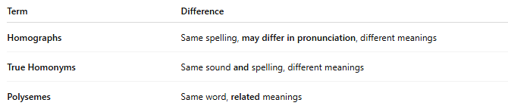
Term | Difference
Homographs | Same spelling, may differ in pronunciation, different meanings
True Homonyms | Same sound and spelling, different meanings
Polysemes | Same word, related meanings

🧭 Classification of Homophones
# Source: Chatgpt (GPT-4-turbo) at [8/1/2025]
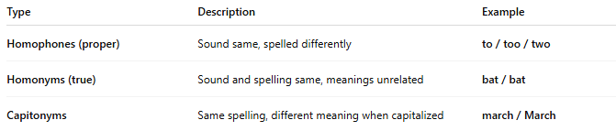
Type | Description | Example
Homophones (proper) | Sound same, spelled differently | to / too / two
Homonyms (true) | Sound and spelling same, meanings unrelated | bat / bat
Capitonyms | Same spelling, different meaning when capitalized | march / March

